**Sea cucumbers**: *Leptosynapta tenuis*

When I was told these were available, I ordered them because they are transparent. They are out of sequence, but only available for a short time every semester.what we have already said about echinoderms. Take photographs of these worm like but **not** annelid creatures. We will look at more echinoderms in the last lab in November. Try to get as many photographs of internal anatomy as you can that you will label in a later lab.

Notice how soft and flexible the body is compared to that of a typical starfish. The body is flexible because the ossicles or the entities that make up the internal skeletons are more widely spaced than in other echinoderms.

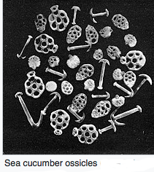

Sea cucumbers are filter feeders, feeding on tiny particles like algae, minute aquatic animals, or waste materials, which they gather in with modified tube feet that look like tentacles surrounding their mouths. They have tube feet at intervals on their bodies as well. They do not use them as much for locomotion as starfish, but often will use them to “glue” themselves in place.

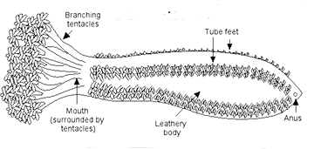

Sea cucumbers have a complete digestive system with two openings: a mouth and anus. They are uniquely anal respirators, meaning they breathe through their rear end. They have respiratory trees that act as ‘lungs’ to transfer oxygen into the body and get rid of carbon dioxide. You may be able to see the digestive tract and respiratory tree in these transparent forms.

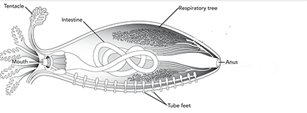

Activity:

If your specimen is already buried in sand, offer it some food. Most sea cucumbers are filter feeders. They will take in any small particle of food they can using their modified tube feet.

After observing your specimen feed, ever so gently with a probe or other blunt instrument unbury your specimen, With a pipette, “wash” the sand from the specimen and view under the scope. Take pictures that you will label at a later date of and internal structures you can see. Be sure to take picture of the “tube feet” that clearly identify the specimen as an echinoderm.

If your specimen is unburied, observe its internal anatomy and than add some sand to the dish to watch it burrow and feed.